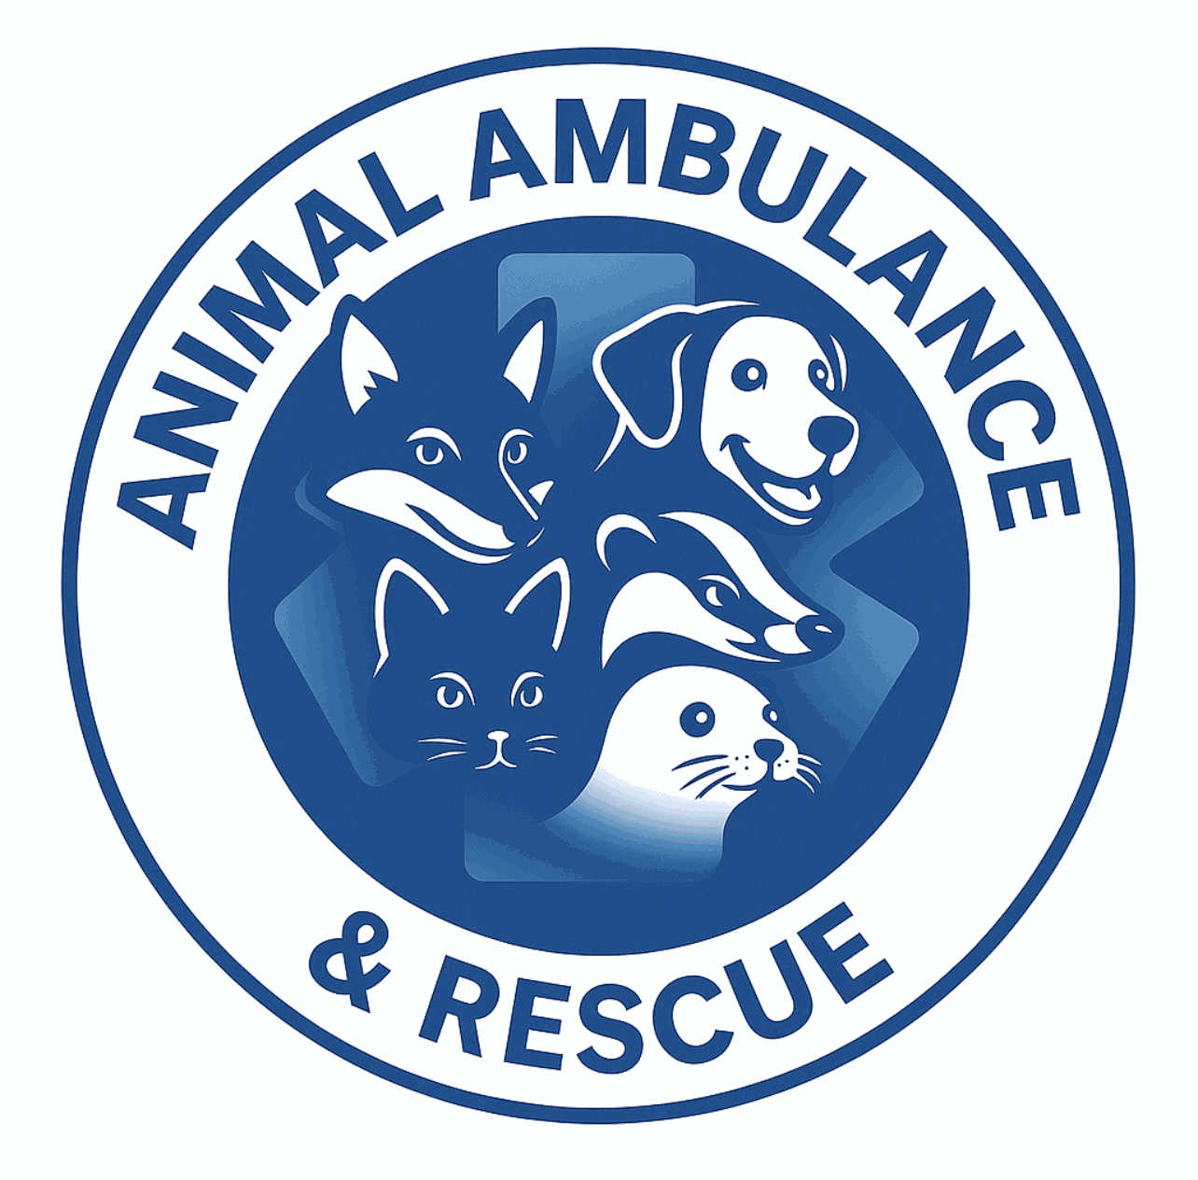

Bank Veterinary Nurse Application Form
Animal Ambulance Service

1. Personal Details
Full Name: _____________________________________________________________________________________
Address: _______________________________________________________________________________________
Postcode: ______________________________________________________________________________________
Phone Number: _______________________________________________________________________________
Email Address: _______________________________________________________________________________
Preferred Contact Method: ☐ Phone ☐ Email

2. Professional Registration
RCVS Registration Number: ________________________________________________________________
Currently registered with RCVS: ☐ Yes ☐ No
Date of Registration: _________________________________________________________________________
Additional Certifications (if any):
__________________________________________________________________________________________________
__________________________________________________________________________________________________
__________________________________________________________________________________________________

3. Employment History (Most Recent First)
Employer: _____________________________________________________________________________________
Position: _______________________________________________________________________________________
Dates Employed (From - To): ______________________________________________________________
Reason for Leaving: ________________________________________________________________________
Key Responsibilities:
_________________________________________________________________________________________________
_________________________________________________________________________________________________
_________________________________________________________________________________________________
_________________________________________________________________________________________________

4. Relevant Experience
Emergency & Critical Care:
_________________________________________________________________________________________________
_________________________________________________________________________________________________
_________________________________________________________________________________________________
Animal Handling (Large & Small Animals):
___________________________________________________________________________________________________
___________________________________________________________________________________________________
___________________________________________________________________________________________________
Ambulance / Field Work / Out-of-Hours Care:
____________________________________________________________________________________________________
____________________________________________________________________________________________________
____________________________________________________________________________________________________

5. Driving & Transport
Full UK Driving Licence: ☐ Yes ☐ No
Licence Number: _______________________________________________________________________________
Any Driving Endorsements: ☐ Yes ☐ No
If yes, please provide details:
___________________________________________________________________________________________________
___________________________________________________________________________________________________
Confident driving larger vehicles (vans/ambulances): ☐ Yes ☐ No

6. Availability (Bank/Zero-Hours)
☐ Weekdays (Day)
☐ Weekdays (Night)
☐ Weekends (Day)
☐ Weekends (Night)
☐ On-call shifts
Additional Notes on Availability:
______________________________________________________________________________________________________
_______________________________________________________________________________________________________

7. Skills & Competencies
☐ Emergency triage
☐ IV catheter placement
☐ Fluid therapy
☐ Monitoring anaesthesia
☐ CPR (RECOVER guidelines)
☐ Wound management
☐ Client communication
☐ Lone working
☐ Euthanasia support
☐ Team leadership
Other relevant skills:
________________________________________________________________________________________________________
________________________________________________________________________________________________________
________________________________________________________________________________________________________

8. Supporting Statement
____________________________________________________________________________________________________
____________________________________________________________________________________________________
____________________________________________________________________________________________________
____________________________________________________________________________________________________
____________________________________________________________________________________________________

9. References
Referee 1
Name: ____________________________________________________________
Position: ____________________________________________________________
Organisation: ____________________________________________________________
Contact Email/Phone: ____________________________________________________________
Referee 2
Name: ____________________________________________________________
Position: ____________________________________________________________
Organisation: ____________________________________________________________
Contact Email/Phone: ____________________________________________________________

10. Declaration
I confirm that the information provided in this application is true and accurate to the best of my knowledge.
Signature: ____________________________________________________________
Date: ____________________________________________________________

